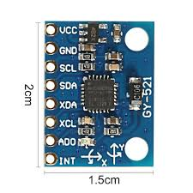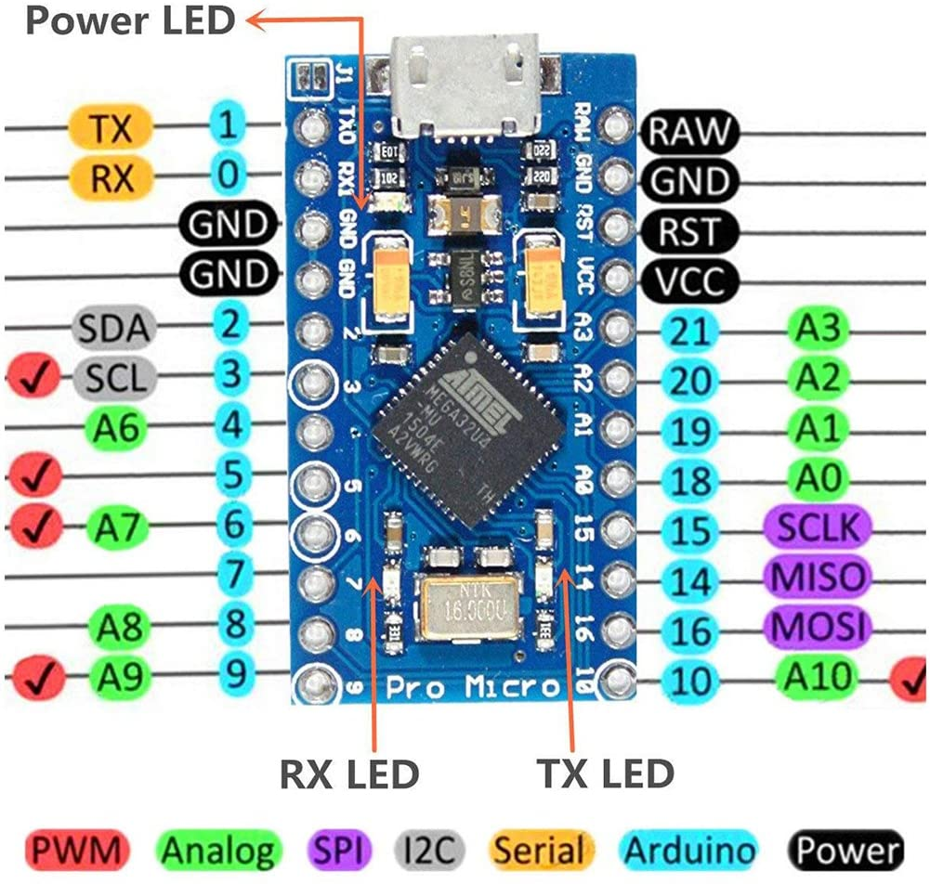

|  |  |  |
| --- | --- | --- |
| Pro Micro |  | Wire colour |
| VCC | MPU 6050 - VCC | Red |
| Gnd (next to pin 2) | MPU 6050 - Gnd | Black |
| Pin 2 | MPU 6050 - SDA | White |
| Pin 3 | MPU6050 - SCL | Yellow |
| Gnd (next to pin 0) | Button 1 (either leg) | Black |
| Pin 9 | Button 1 (either leg) | Green |
| Gnd (inbetween RAW and RST) | Button 2 (either leg) | Black |
| Pin 10 | Button 2 (either leg) | Blue |